[E142] Olimex panel

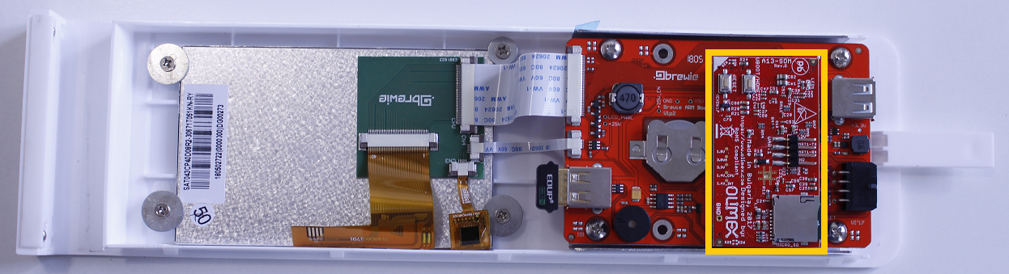

The Olimex panel is located in the front panel assembly.

Check [E119] about how to remove the front panel from the B+.

With a screwdriver gently move the panel off the pins of the ARM panel.

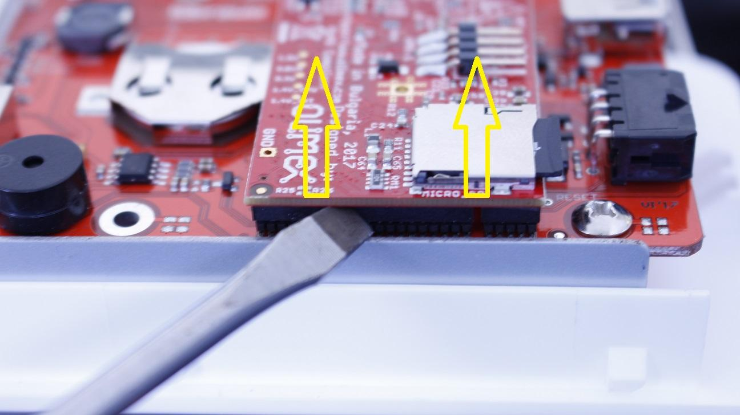

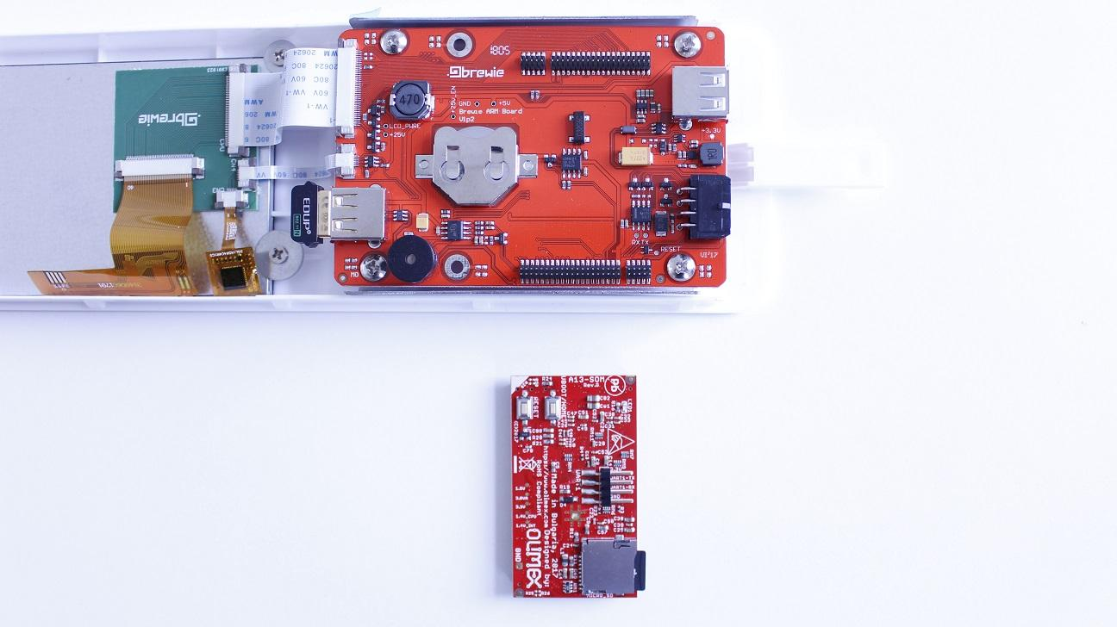

Take out the SD card from the Olimex panel (Check [E144]).

The Olimex panel can be replaced now.

Reassemble consists of the same steps in reverse.

IMPORTANT! The same SD card has to be placed in the panel as each machine has its own configuration and calibration data stored on the SD card.